HCCB Files formatting
- First 4 Row horizontal column (-)
- Add 1 Column ( Plant)
- Ameenpur Beverage/Moula Ali Beverage :- 1162 Plant
- Vijaywada Beverage/Vizag Beverage/Chittoor Beverage:-1181 Plant
- Call Log Date ( Change Format Old-29/12/2025 , change-29-12-2025)
- 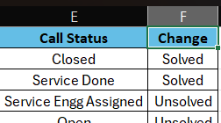

- Put the this format data

Cadbury Files Formatting
- Open Files
- Delimited
- Change date 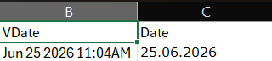
- Service_Provider(-)/Span Spectrum Pvt Ltd/Punjab Refrigeration
- Add 1 Column +Plant Name
- Put the this format data

